QUESTION-3
3. Write a C program for Playfair algorithm is based on the use of a 5 X 5 matrix of letters constructed using a keyword. Plaintext is encrypted two letters at a time using this matrix.

AIM
To write a C program to implement the Playfair cipher, which uses a 5 × 5 matrix of letters constructed from a keyword to encrypt plaintext two letters at a time.
PROCEDURE
- Start the program.
- Read the keyword from the user.
- Construct a 5 × 5 matrix using the keyword.
- Remove duplicate letters from the keyword.
- Combine I and J into a single cell.
- Fill the remaining spaces with unused letters of the alphabet.
- Read the plaintext.
- Divide the plaintext into pairs of letters.
- If both letters in a pair are the same, insert X between them.
- For each pair:
  - Same row: Replace each letter with the letter to its right.
  - Same column: Replace each letter with the letter below it.
  - Different row and column: Replace each letter with the letter in the same row as itself but the column of the other letter.
- Display the encrypted ciphertext.
- Stop the program.
C CODE
C
#include <stdio.h>
#include <string.h>
#include <ctype.h>

char matrix[5][5];

/* Check whether a character is already present */
int isUsed(char ch, char used[])
{
int i;

if (ch == 'J')
ch = 'I';

for (i = 0; used[i] != '\0'; i++)
{
if (used[i] == ch)
return 1;
}

return 0;
}

/* Create the 5 x 5 Playfair matrix */
void createMatrix(char key[])
{
char used[26] = "";
int row = 0, col = 0;
int i, j;
char ch;

/* Add keyword letters */
for (i = 0; key[i] != '\0'; i++)
{
ch = toupper(key[i]);

if (ch < 'A' || ch > 'Z')
continue;

if (ch == 'J')
ch = 'I';

if (!isUsed(ch, used))
{
int len = strlen(used);
used[len] = ch;
used[len + 1] = '\0';

matrix[row][col] = ch;
col++;

if (col == 5)
{
col = 0;
row++;
}
}
}

/* Add remaining alphabet letters */
for (ch = 'A'; ch <= 'Z'; ch++)
{
if (ch == 'J')
continue;

if (!isUsed(ch, used))
{
int len = strlen(used);
used[len] = ch;
used[len + 1] = '\0';

matrix[row][col] = ch;
col++;

if (col == 5)
{
col = 0;
row++;
}
}
}
}

/* Find row and column of a character */
void findPosition(char ch, int *row, int *col)
{
int i, j;

if (ch == 'J')
ch = 'I';

for (i = 0; i < 5; i++)
{
for (j = 0; j < 5; j++)
{
if (matrix[i][j] == ch)
{
*row = i;
*col = j;
return;
}
}
}
}

/* Encrypt plaintext */
void encrypt(char plaintext[], char ciphertext[])
{
char prepared[200];
int i = 0, j = 0;
int r1, c1, r2, c2;

/* Prepare plaintext */
while (plaintext[i] != '\0')
{
if (isalpha(plaintext[i]))
{
char ch = toupper(plaintext[i]);

if (ch == 'J')
ch = 'I';

prepared[j++] = ch;
}
i++;
}

prepared[j] = '\0';

/* Add X between repeated letters */
char finalText[200];
int p = 0, q = 0;

while (prepared[p] != '\0')
{
finalText[q++] = prepared[p];

if (prepared[p + 1] != '\0' &&
prepared[p] == prepared[p + 1])
{
finalText[q++] = 'X';
p++;
}
else
{
if (prepared[p + 1] != '\0')
{
finalText[q++] = prepared[p + 1];
p += 2;
}
else
{
p++;
}
}
}

/* If odd number of letters, add X */
if (q % 2 != 0)
finalText[q++] = 'X';

finalText[q] = '\0';

/* Encrypt each pair */
for (i = 0; i < q; i += 2)
{
findPosition(finalText[i], &r1, &c1);
findPosition(finalText[i + 1], &r2, &c2);

if (r1 == r2)
{
ciphertext[i] = matrix[r1][(c1 + 1) % 5];
ciphertext[i + 1] = matrix[r2][(c2 + 1) % 5];
}
else if (c1 == c2)
{
ciphertext[i] = matrix[(r1 + 1) % 5][c1];
ciphertext[i + 1] = matrix[(r2 + 1) % 5][c2];
}
else
{
ciphertext[i] = matrix[r1][c2];
ciphertext[i + 1] = matrix[r2][c1];
}
}

ciphertext[q] = '\0';
}

int main()
{
char key[100];
char plaintext[200];
char ciphertext[200];

printf("Enter the keyword: ");
fgets(key, sizeof(key), stdin);
key[strcspn(key, "\n")] = '\0';

createMatrix(key);

printf("\nPlayfair Matrix:\n");

for (int i = 0; i < 5; i++)
{
for (int j = 0; j < 5; j++)
{
printf("%c ", matrix[i][j]);
}
printf("\n");
}

printf("\nEnter the plaintext: ");
fgets(plaintext, sizeof(plaintext), stdin);

encrypt(plaintext, ciphertext);

printf("Encrypted text: %s\n", ciphertext);

return 0;
}
SAMPLE INPUT
For example, take:
Enter the keyword: MONARCHY
Enter the plaintext: HELLO WORLD
Playfair Matrix
M O N A R
C H Y B D
E F G I K
L P Q S T
U V W X Z
The plaintext is prepared as pairs:
HE LX LO WO RL DX

SAMPLE OUTPUT
Encrypted text: CFSUPVMNDAQY

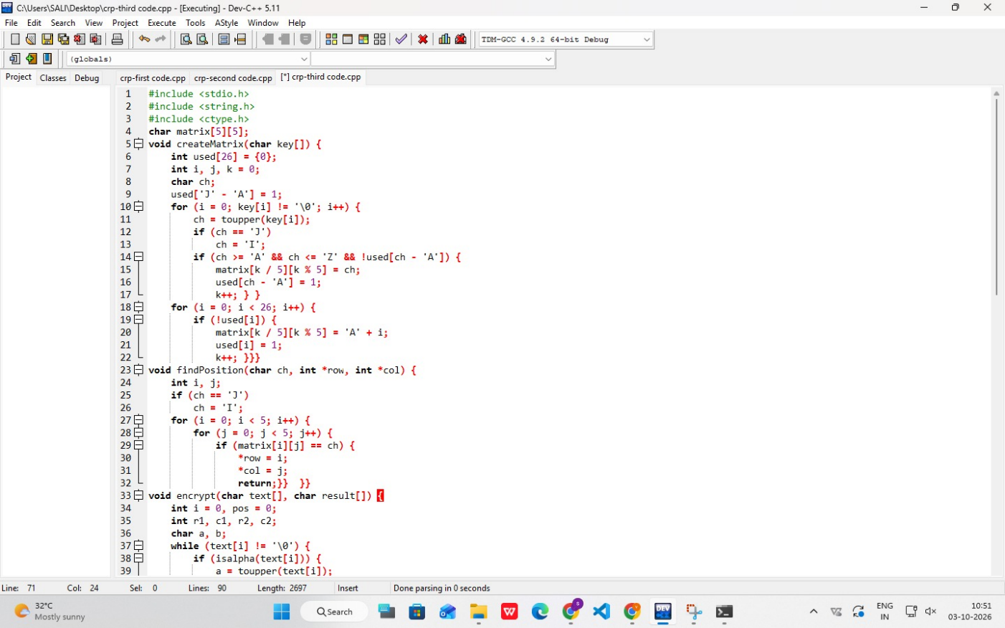
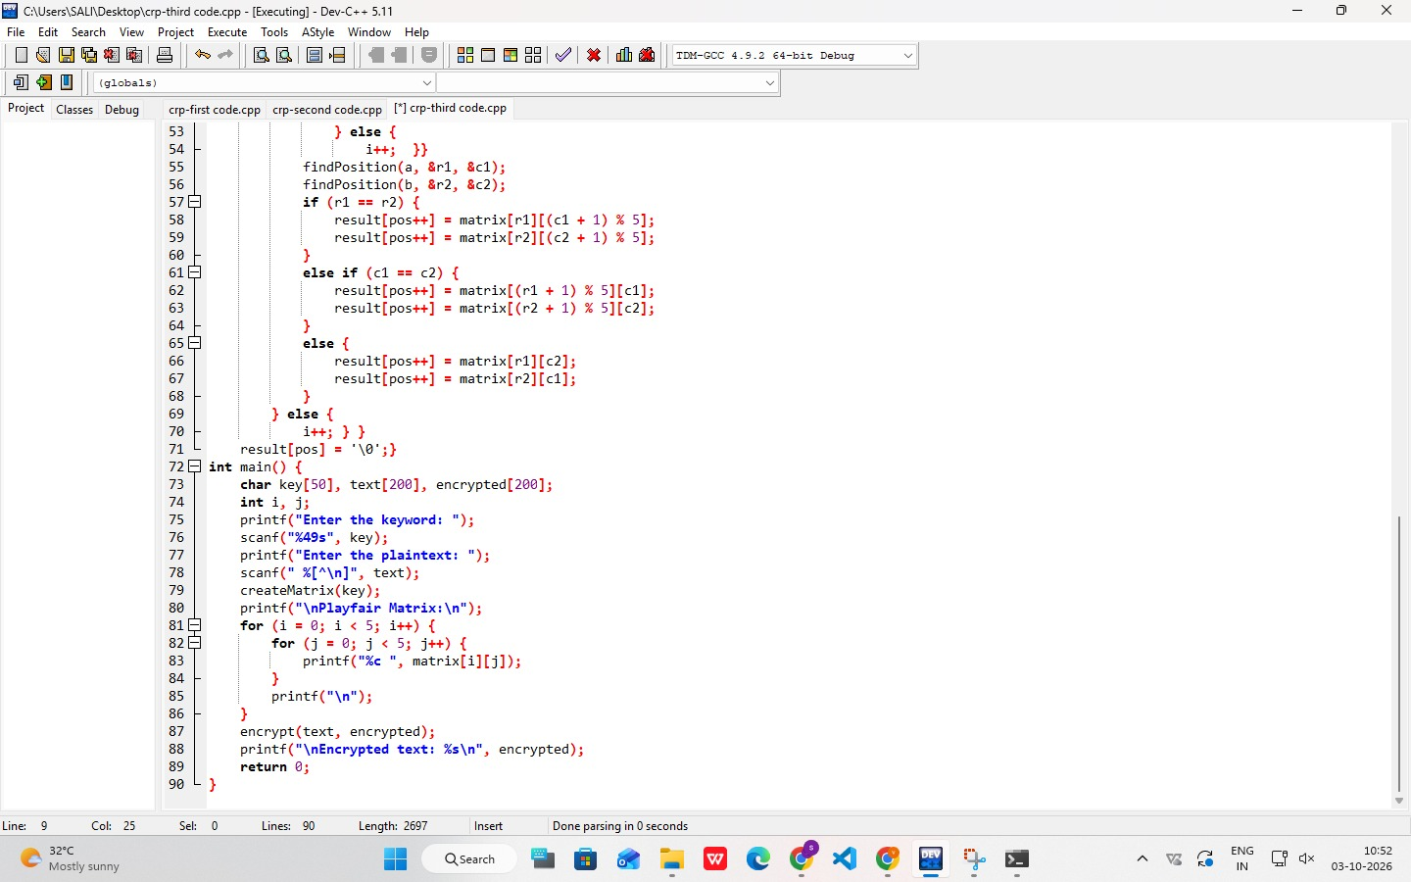
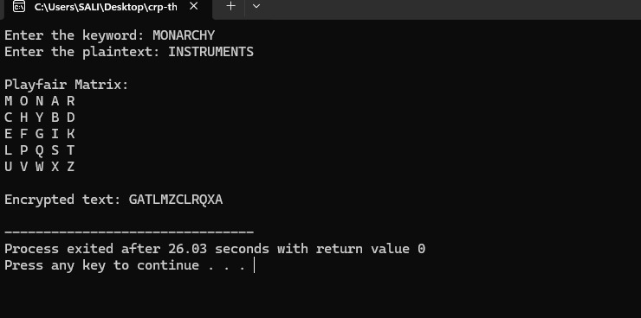
RESULT
Thus, the Playfair cipher was successfully implemented in C using a 5 × 5 key matrix, and the plaintext was encrypted in pairs according to the Playfair encryption rules.

